Smart water management

# **Introduction:**

Water is a finite and essential resource for life on Earth, yet it is under threat due to increasing population, urbanization, pollution, and climate change. The inefficient use and management of water resources have led to a looming global water crisis. To address this critical issue, the implementation of smart water management systems is imperative. This one-page write-up outlines the problem statement, highlighting the urgency and need for smart water management solutions.

## **Components:**

Smart water management involves the use of technology and data to efficiently and sustainably manage water resources. Some key components

1. Sensors: IoT (Internet of Things) sensors collect data on water quality, usage, and infrastructure conditions.

2. Data Analytics: Algorithms process sensor data to detect anomalies, predict usage, and optimize water distribution.

3. Remote Monitoring: Real-time monitoring and control of water systems through cloud-based platforms.

4. Automated Control Systems: Smart valves and pumps adjust water flow based on demand and data.

5. Leak Detection: Continuous monitoring to identify and locate water leaks in the distribution network.

6. Water Quality Monitoring: Sensors measure parameters like pH, turbidity, and contaminants.

7. Demand Response: Encouraging consumers to use water during off-peak hours to reduce stress on the system.

8. Asset Management: Using data to maintain and optimize water infrastructure, like pipes and treatment plants.

9. Customer Engagement: Providing consumers with insights into their water usage to encourage conservation.

10. Integration with GIS: Geographic Information Systems for mapping and visualizing water-related data.

## **Circuit diagram:**

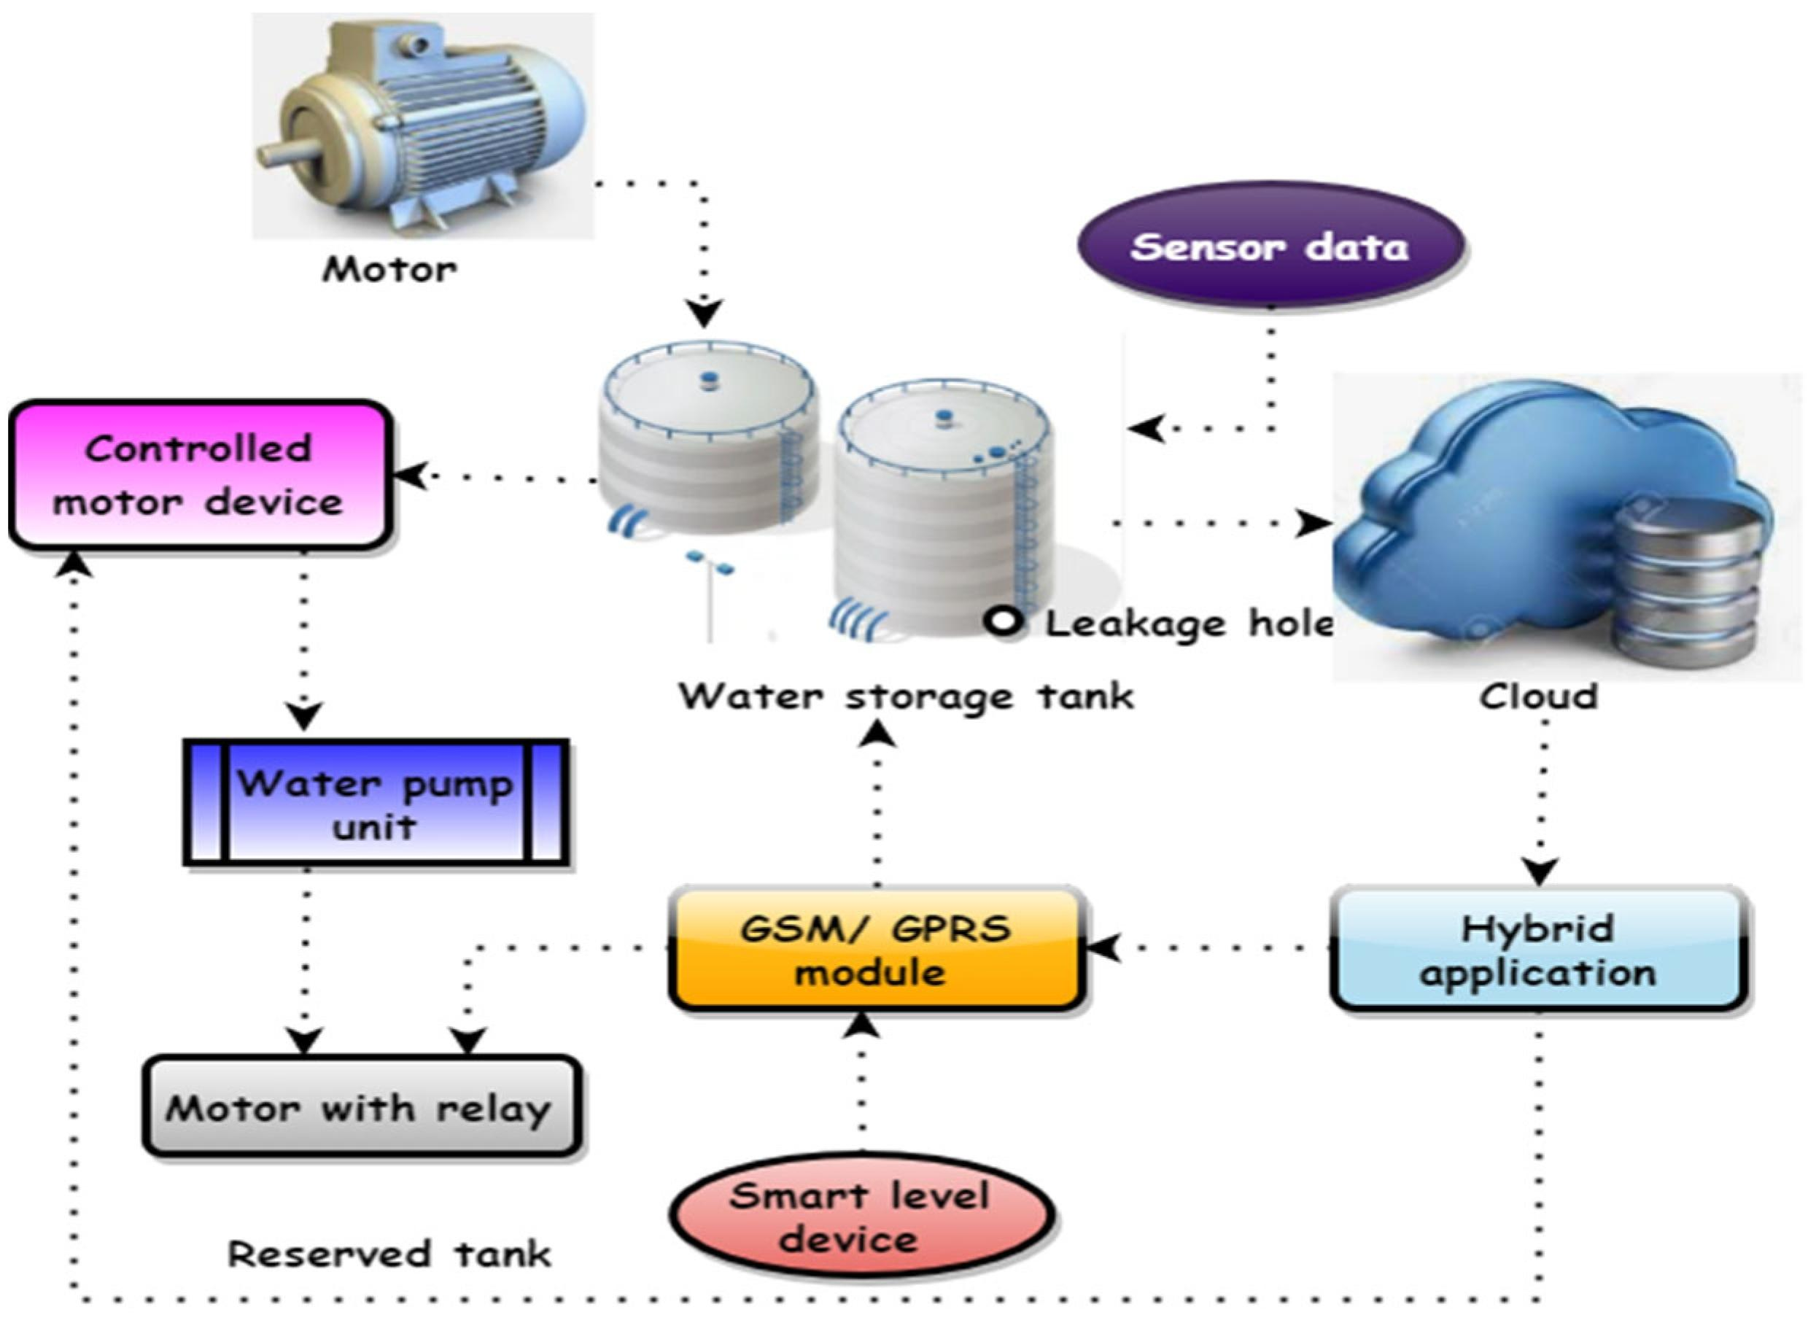

## **Program:**

```javascript

// Simulated water level sensor data (in centimeters)

Const waterLevelSensor = {

currentLevel: 20,

idealLevel: 50

};

// Function to check water level and control water usage

Function checkWaterLevel() {

If (waterLevelSensor.currentLevel < waterLevelSensor.idealLevel) {

Console.log(“Water level is low. Initiating water supply…”);

// Code to activate water supply system goes here

} else {

Console.log(“Water level is sufficient. No action needed.”);

// Code to stop water supply system goes here

}

}

// Simulate changing water levels (for demonstration purposes)

Function simulateWaterLevelChange() {

setInterval(() => {

// Randomly change water level between 0 and 100 cm

waterLevelSensor.currentLevel = Math.floor(Math.random() * 101);

console.log(“Current water level: “ + waterLevelSensor.currentLevel + “ cm”);

checkWaterLevel();

}, 5000); // Simulate every 5 seconds

}

// Start simulating water level changes

simulateWaterLevelChange();

## **Specifications:**

## **Hardware**:

1. Sound Sensor: Captures environmental noise.
2. Microcontroller (e.g., Arduino or Raspberry Pi): Processes and manages data.
3. Communication Module (e.g., Wi-Fi, GSM): Transmits data to a central server.
4. Power Supply: Ensure a reliable and efficient power source.
5. Enclosure: Protects the components from environmental factors.

## **Software:**

1. Embedded Software for Microcontroller: Programs the microcontroller for data Collection and transmission.

2. Server-side Software: Manages and analyzes the received data.

3. Database: Stores historical noise data for analysis.

## **Python script:**

import water_sensor

import time

def monitor_water_level():

while True:

water_level = water_sensor.get_water_level()

if water_level < 30: # Adjust threshold as needed

send_alert("Low water level detected!")

time.sleep(3600) # Check water level every hour

def send_alert(message):

# Implement alerting mechanism (e.g., email or SMS)

print(f"Alert: {message}")

if __name__ == "__main__":

monitor_water_level()

## **Advantages:**

* Reducing waste of water-intensive industries. ...
* Monitoring water quality to fight pollution and diseases. ...
* Improving the efficiency of water systems. ...
* Creating awareness of household water use thanks to smart meters.

## **Disadvantages:**

* High installation costs: Smart water meters can be expensive to install, and some households may not be able to afford the upfront costs. …
* Privacy concerns: Smart water meters can collect data on household water usage, raising privacy concerns.

## **Conclusion:**

Smart water management is essential for the sustainable use of this vital resource. It involves the integration of technology, data, and proactive strategies to optimize water distribution, reduce wastage, and ensure reliable access. This approach helps conserve water, lower operational costs, and mitigate the impact of water scarcity. In conclusion, smart water management is crucial for environmental conservation, economic efficiency, and long-term water security.